

**DIGITAL ASSIGNMENT 1**

**NAME: AYUSH SHARMA**

**REGISTER NUMBER: 21BDS0058**

**COURSE CODE: BCSE302P**

**COURSE NAME: DATABASE SYSTEM LAB**

**Aim:** To study Data Definition and Data Manipulation Commands

**Exercise - 1:**

Create the student schema as follows

STUDENT (Regno, Fname, Lname, Phone, Address) SQL Command:

create table Student(RegNo varchar(10), First_Name varchar(50), Last_Name varchar(50), Phone int, Address varchar(50));

Screenshot: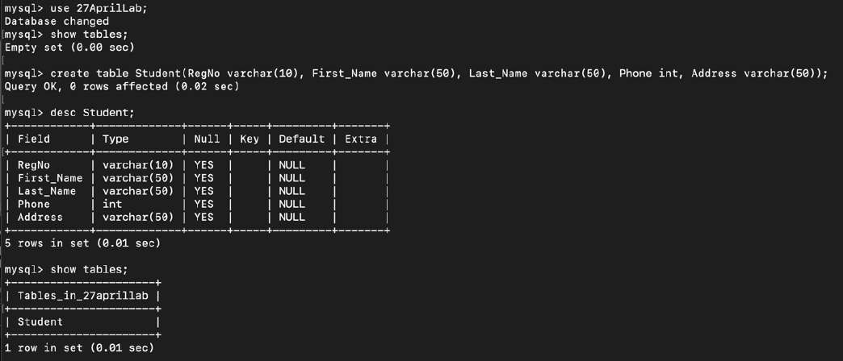

1. Add a column Email_id SQL Command:

alter table Student add Email_ID varchar(50);

Screenshot:s

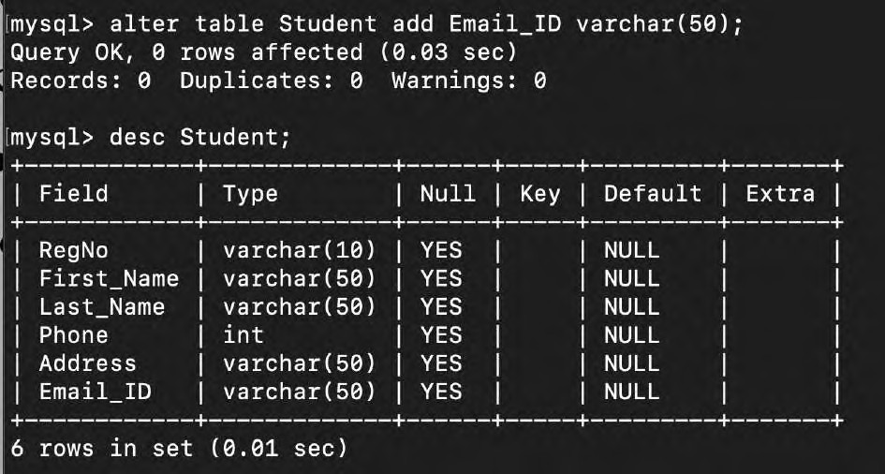

1. Remove the column Address SQL Command:

alter table Student drop column Address;

Screenshot:

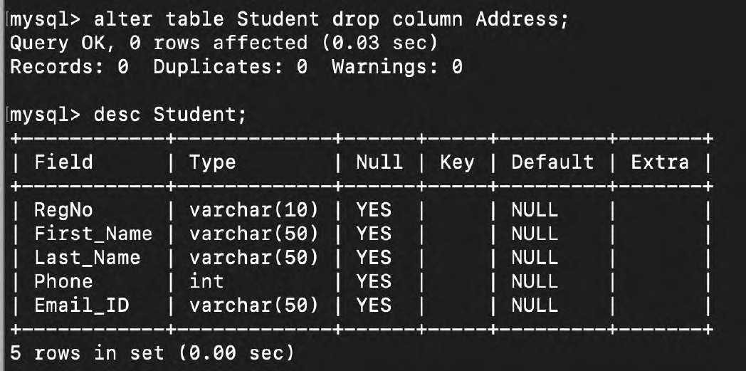

1. Modify the column Phone with size 10. SQL Command:

alter table Student modify Phone int(10);

Screenshot:

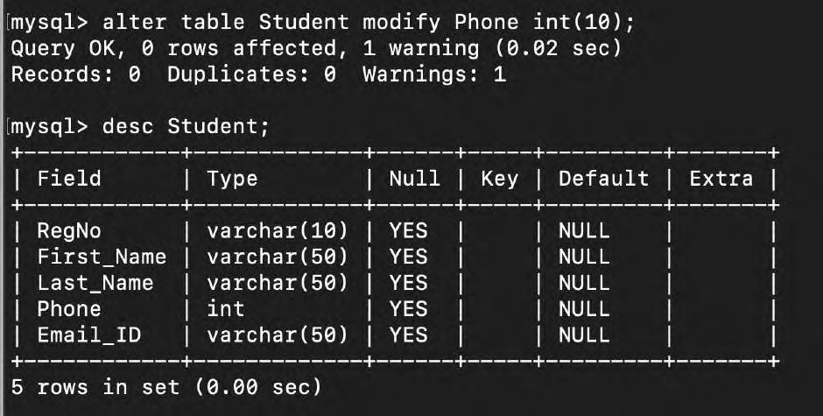

1. Rename a column Phone by Mobile_no. SQL Commands:

alter table Student rename column Phone to Mobile_No;

Screenshot:

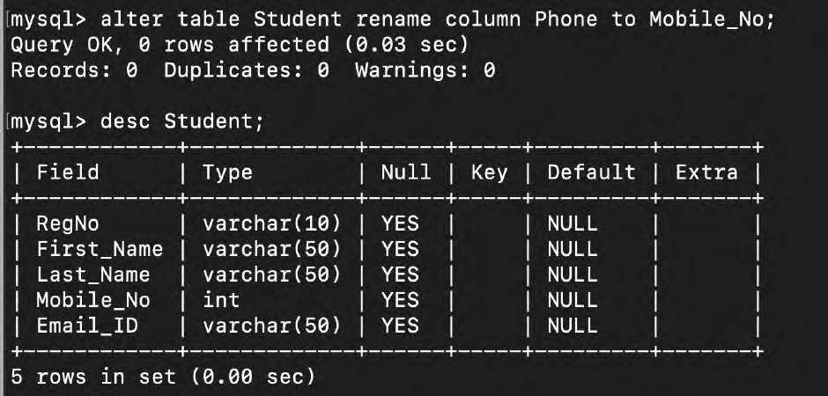

1. Rename the table name STUDENT by STUDENTS SQL Commands:

rename table Student to Students;

Screenshot:

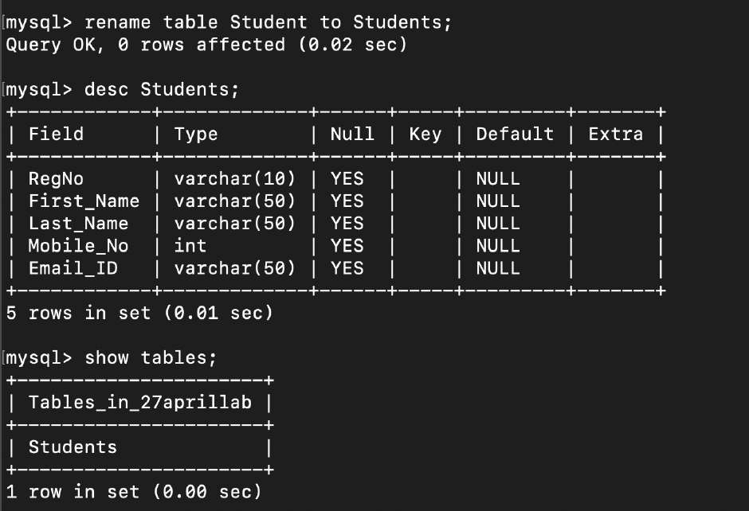

1. Insert 10 students records in STUDENTS table SQL Commands:

insert into Students(RegNo, First_Name, Last_Name, Mobile_No, Email_ID) values ('21BCE0413', 'Ayush', 'Sharma', '1234567890', 'Ayush.Sharma@gmail.com');

insert into Students(RegNo, First_Name, Last_Name, Mobile_No, Email_ID) values ('970657454', 'Briony', 'Carroll', '1234567890', 'b.carroll@randatmail.com');

insert into Students(RegNo, First_Name, Last_Name, Mobile_No, Email_ID) values ('473320758', 'Albert', 'Perkins', '1234567890', 'a.perkins@randatmail.com');

insert into Students(RegNo, First_Name, Last_Name, Mobile_No, Email_ID) values ('505753120', 'Kate', 'Turner', '1234567890', 'k.turner@randatmail.com');

insert into Students(RegNo, First_Name, Last_Name, Mobile_No, Email_ID) values ('133311212', 'Freddie', 'Thomas', '1234567890', 'f.thomas@randatmail.com');

insert into Students(RegNo, First_Name, Last_Name, Mobile_No, Email_ID) values ('799482255', 'Roman', 'Mason', '1234567890', 'r.mason@randatmail.com');

insert into Students(RegNo, First_Name, Last_Name, Mobile_No, Email_ID) values ('129905906', 'Carl', 'Reed', '1234567890', 'c.reed@randatmail.com');

insert into Students(RegNo, First_Name, Last_Name, Mobile_No, Email_ID) values ('760847342', 'Harold', 'Andrews', '1234567890', 'h.andrews@randatmail.com');

insert into Students(RegNo, First_Name, Last_Name, Mobile_No, Email_ID) values ('748521953', 'Aldus', 'Wilson', '1234567890', 'a.wilson@randatmail.com');

insert into Students(RegNo, First_Name, Last_Name, Mobile_No, Email_ID) values ('769171470', 'Caroline', 'Spencer', '1234567890', 'c.spencer@randatmail.com');

Screenshot:

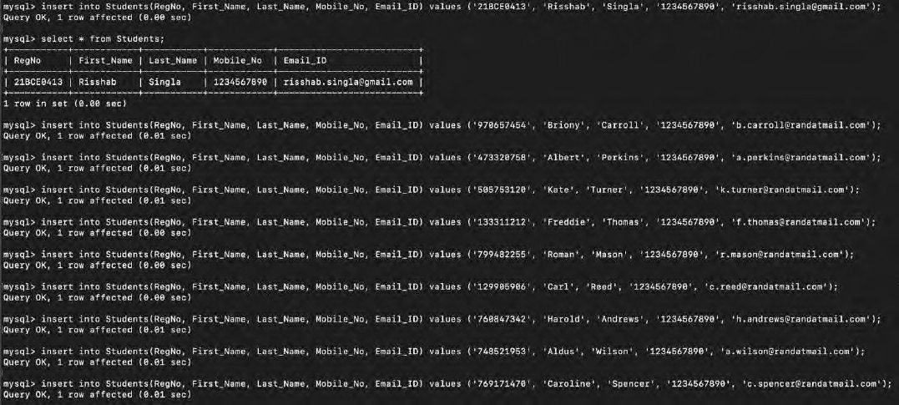

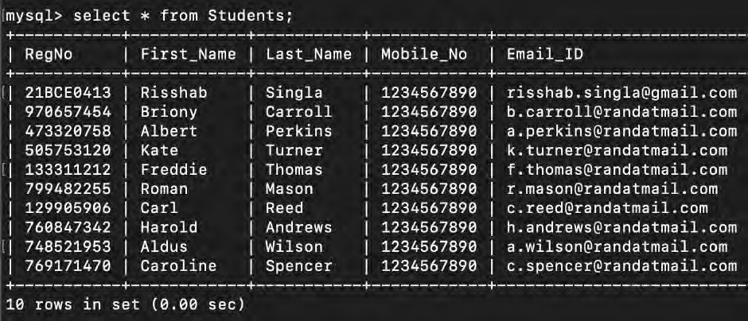

1. Show the table description SQL Commands:

desc Students;

Screenshot:

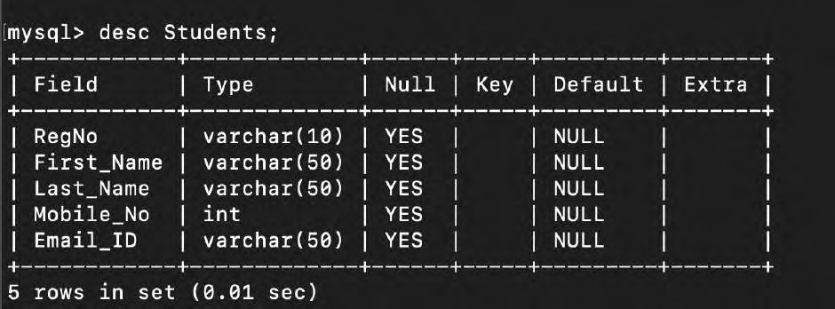

1. Display all the records SQL Commands:

Select * from Students;

Screenshot:

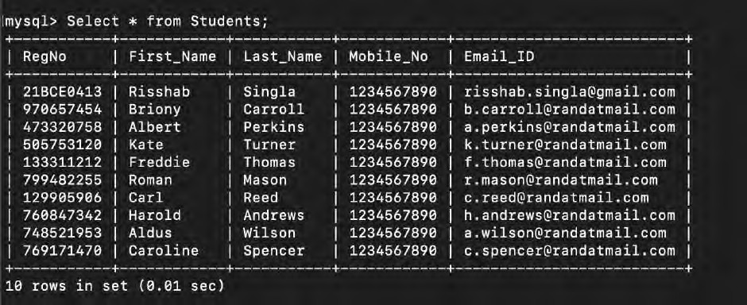

1. Delete all the records SQL Commands:

delete from Students;

Screenshot:

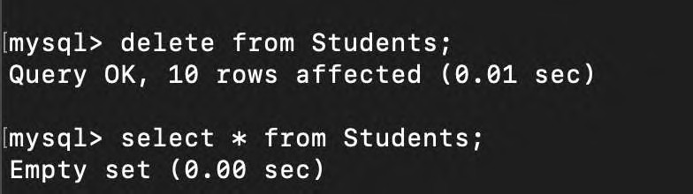

1. Drop the table SQL Commands:

drop table Students;

Screenshot:

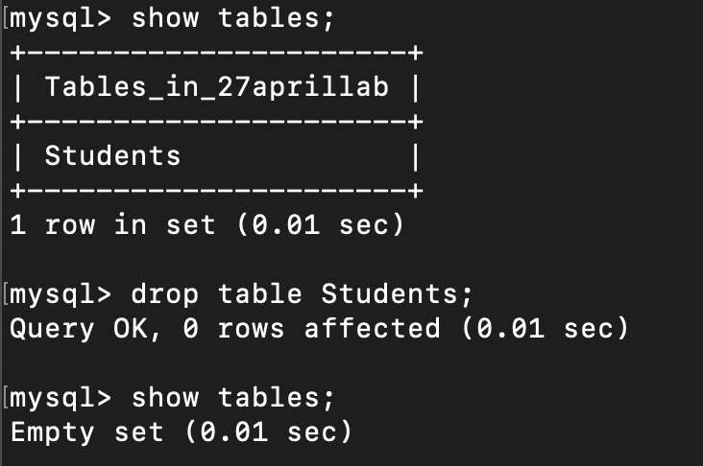

**Exercise-II:**

1. Insert the data given above in both employee, department and project tables.

# Creating the tables:

SQL Commands:

create table Employee(First_Name varchar(15),Mid_Name char(2) , Last_Name varchar(15), SSN_Number char(9), Birthday date, Address varchar(50), Sex char(1), Salary integer(7), Supervisor_SSN char(9), Department_Number integer(5));

create table Department (Department_Name varchar(15), Department_Number integer(5), Manager_SSN char(9), Manage_Start_Date date);

create table Project(Project_Name varchar(15), Project_Number integer(5), Project_Location varchar(15), Department_Number integer(5));

Screenshot:

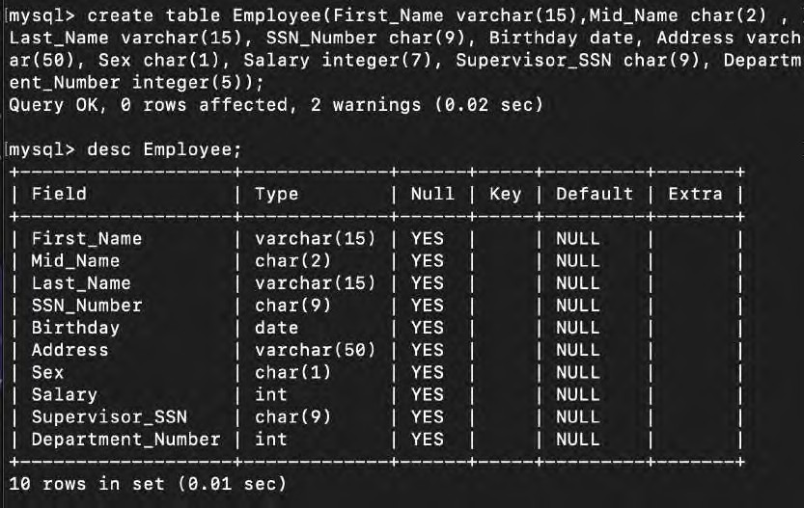

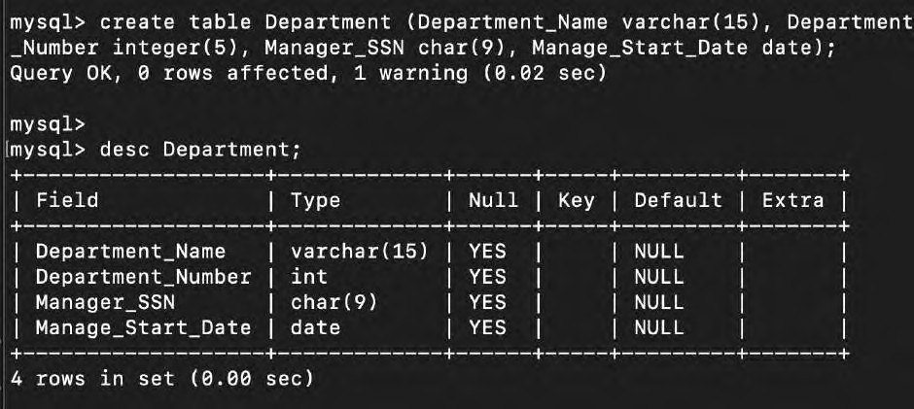

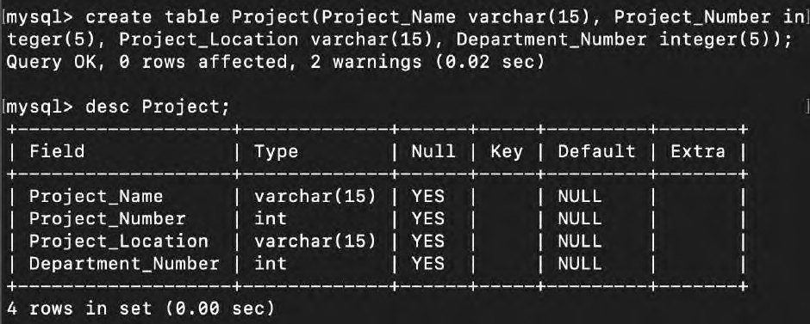

# Inserting the Employee data :

SQL Commands:

insert into Employee (First_Name, Mid_Name, Last_Name, SSN_Number, Birthday, Address, Sex, Salary, Department_Number) values ('Doug', 'E', 'Gilbert', '123', '1968-07-09', 'Chennai', 'M', '80000', '1');

insert into Employee (First_Name, Last_Name, SSN_Number, Birthday, Address, Sex, Salary, Department_Number) values ('Joyce','PAN', '124', '1973-02-07', 'Vellore', 'F',

'70000', '1');

insert into Employee (First_Name, Mid_Name, Last_Name, SSN_Number, Birthday, Address, Sex, Salary, Supervisor_SSN,

Department_Number) values ('Franklin', 'T', 'Wong', '125', '1972-12-08', 'Delhi', 'M', '40000', '123', '2');

insert into Employee (First_Name, Mid_Name, Last_Name, SSN_Number, Birthday, Address, Sex, Salary, Supervisor_SSN, Department_Number) values ('Jennifer', 'S', 'Wallace', '564', '1983-06-20', 'Chennai', 'F', '43000', '123', '2');

insert into Employee (First_Name, Mid_Name, Last_Name, SSN_Number, Birthday, Address, Sex, Salary, Supervisor_SSN, Department_Number) values ('John', 'B', 'Smith', '678', '1987-01-09', 'Madurai', 'M', '30000', '124', '1');

insert into Employee (First_Name, Mid_Name, Last_Name, SSN_Number, Birthday, Address, Sex, Salary, Supervisor_SSN, Department_Number) values ('Ramesh', 'K', 'Narayan', '234', '1985-09-15', 'Bangalore', 'M', '38000', '124', '3');

Screenshot:

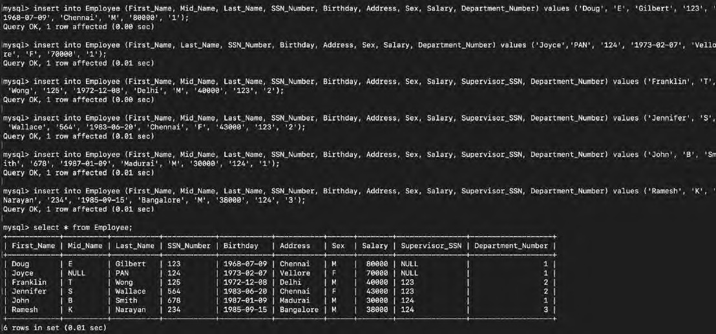

# Inserting the Department data :

SQL Commands:

insert into Department (Department_Name, Department_Number, Manager_SSN , Manage_Start_Date) values ('Administration', '2', '564', '2012-01-03');

insert into Department (Department_Name, Department_Number, Manager_SSN , Manage_Start_Date) values ('Headquarter', '1', '678', '2014-12-16');

insert into Department (Department_Name, Department_Number, Manager_SSN , Manage_Start_Date) values ('Finance', '3', '234', '2013-05-18');

insert into Department (Department_Name, Department_Number, Manager_SSN , Manage_Start_Date) values ('IT', '4', '123', '2015-06-12');

Screenshot:

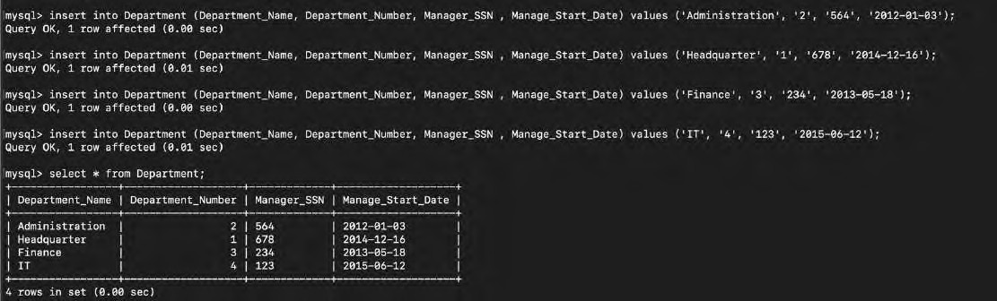

# Inserting the Project Data:

SQL Commands:

insert into Project (Project_Name, Project_Number, Project_Location , Department_Number) values ('ProjectA', '3388', 'Delhi', '1');

insert into Project (Project_Name, Project_Number, Project_Location , Department_Number) values ('ProjectB', '1945', 'Hyderabad', '1');

insert into Project (Project_Name, Project_Number, Project_Location , Department_Number) values ('ProjectC', '6688', 'Chennai', '2');

insert into Project (Project_Name, Project_Number, Project_Location , Department_Number) values ('ProjectD', '2423', 'Chennai', '2');

insert into Project (Project_Name, Project_Number, Project_Location , Department_Number) values ('ProjectE', '7745', 'Bangalore', '3');

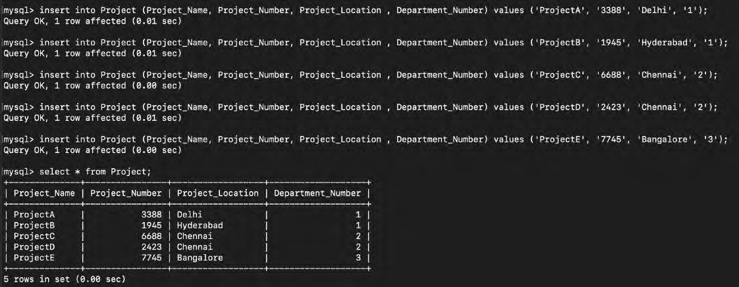Screenshot:

# Display all the employees’ information.

SQL Commands:

select * from Employee;

Screenshot:

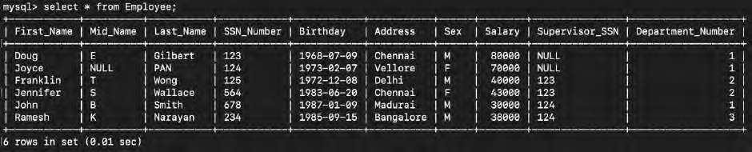

# Display Employee name along with his SSN and Supervisor SSN.

SQL Commands:

select First_Name, Mid_Name, Last_Name, SSN_Number, Supervisor_SSN from Employee;

Screenshot:

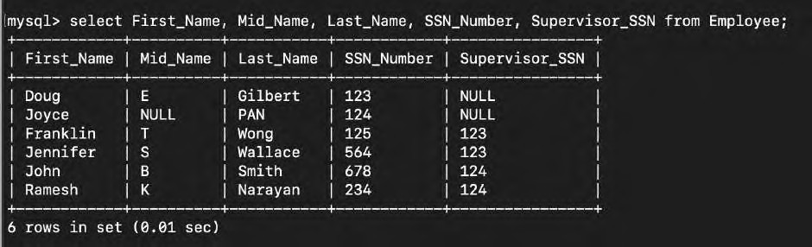

# Display the employee names whose bdate is ’20-JUN-1983’.

SQL Commands:

select First_Name, Mid_Name, Last_Name from Employee where Birthday = '1983-06-20';

Screenshot:

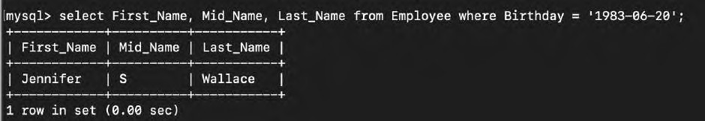

# Display salary of the employees without duplications.

SQL Commands:

select distinct Salary from Employee;

Screenshot:

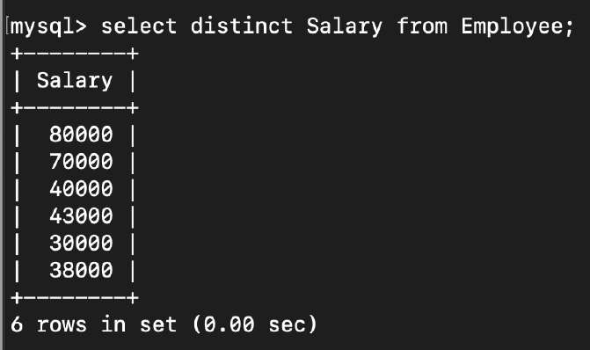

# Display the MgrSSN, MgrStartDate of the manager of ‘Finance’ department.

SQL Command:

select Manager_SSN, Manage_Start_Date from Department where Department_Name = 'Finance';

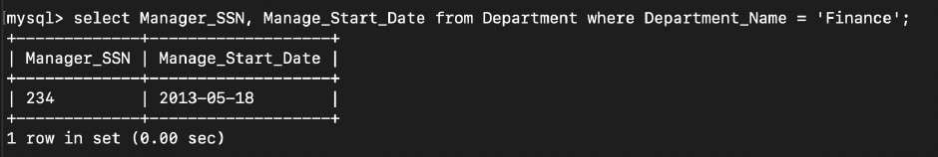Screenshot:

# Modify the department number of an employee having fname as ‘Joyce’ to 5

SQL Command:

update Employee set Department_Number ='5' where First_Name = 'Joyce';

Screenshot:

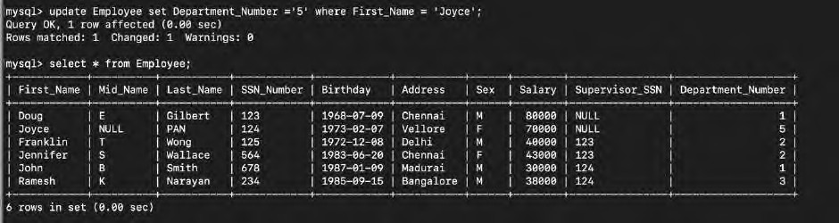

# Alter Table department add column DepartmentPhoneNum of NUMBER data type and insert values into this column only.

Altering the table:

SQL Command:

alter table Department add column Department_Phone_Number int(10);

Screenshot:

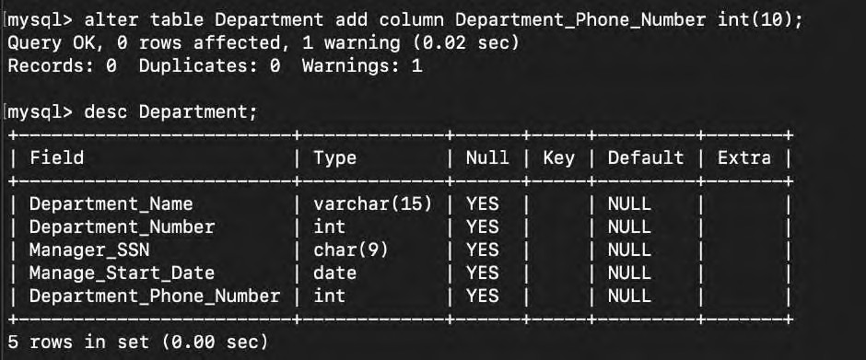

Inserting the values:

SQL Command:

update Department set Department_Phone_Number = '1234567890' where Department_Name = 'Administration';

update Department set Department_Phone_Number = '1243567890' where Department_Name = 'Headquarter';

update Department set Department_Phone_Number = '1243523410' where Department_Name = 'Finance';

update Department set Department_Phone_Number = '1961567890' where Department_Name = 'IT';

Screenshot:

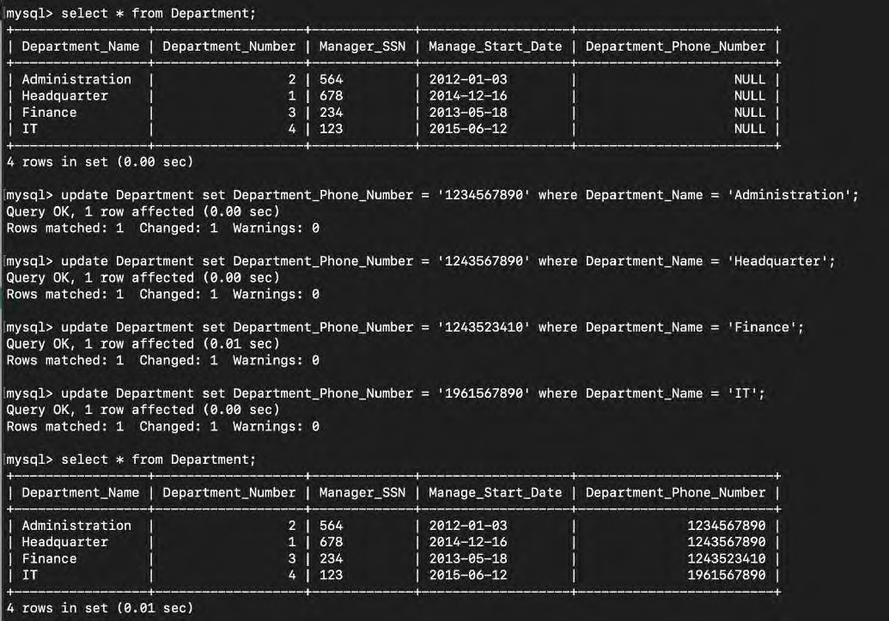

# Alter table department to modify the size of DepartmentPhoneNum.

SQL Command:

alter table Department modify column Department_Phone_Number int(2);

Screenshot:

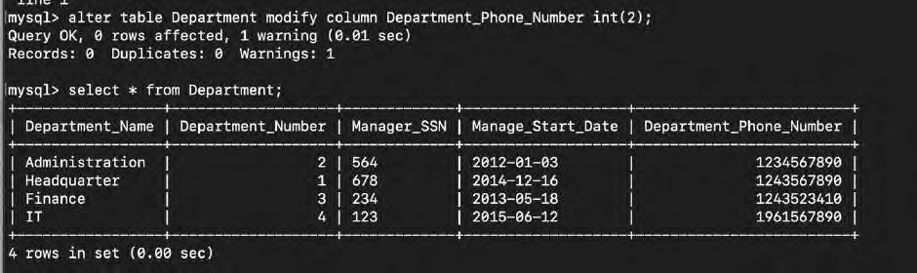

# Modify the field name DepartmentPhoneNum of departments table to PhNo.

SQL Command:

alter table Department rename column Department_Phone_Number to Ph_No;

Screenshot:

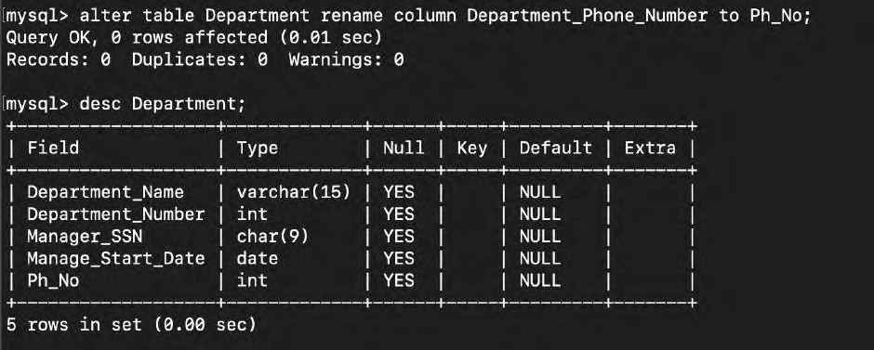

# Rename Table Department as DEPT.

SQL Command:

rename table Department to DEPT;

Screenshot:

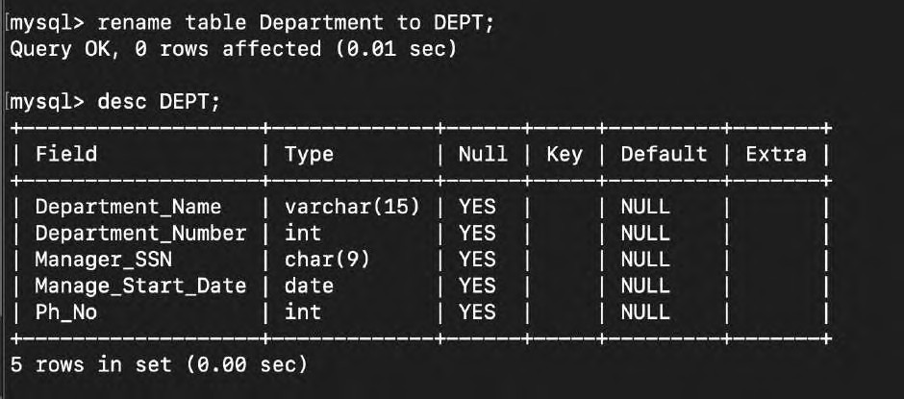

# Alter Table department remove column PhNo.

SQL Command:

alter table DEPT drop column Ph_No;

Screenshot:

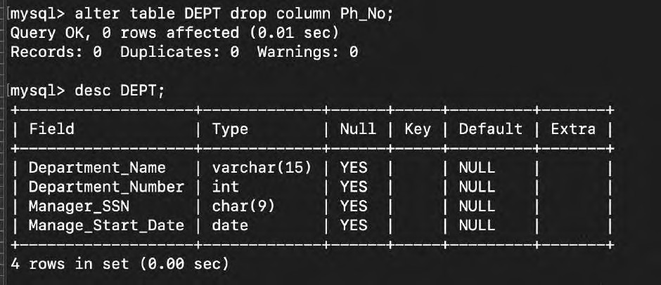

# Create a table COPYOFDEPT as a copy of the table DEPT.

SQL Command:

create table CopyOfDEPT like DEPT;

insert into CopyOfDEPT Select * from DEPT;

Screenshot:

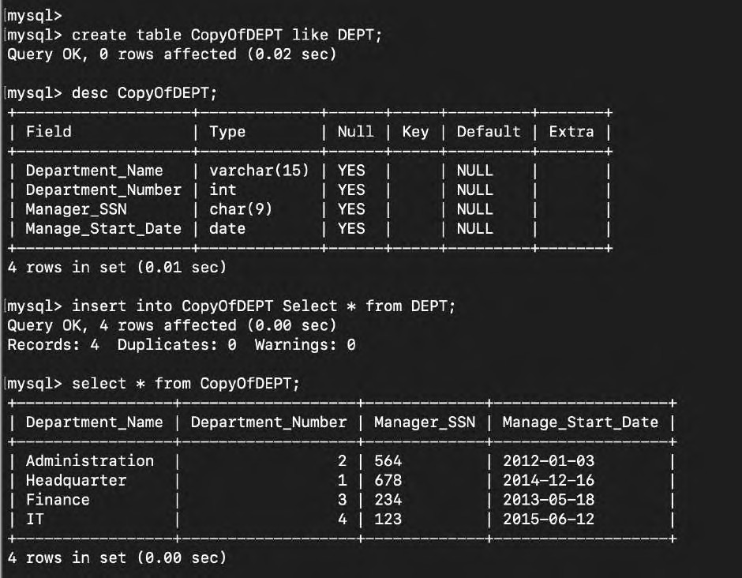

# Delete all the rows from COPYOF DEPT table.

SQL Command:

delete from CopyOfDEPT;

Screenshot:

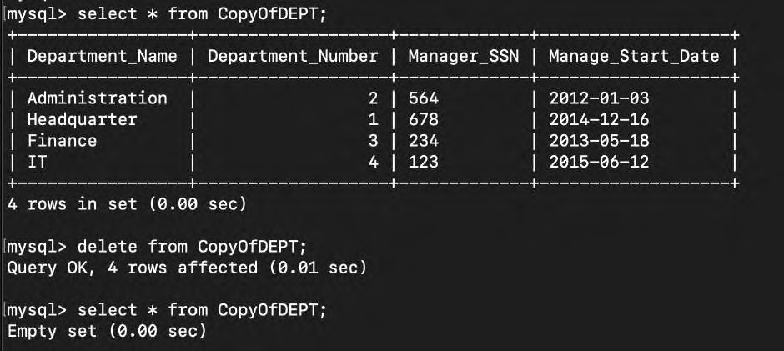

# Remove COPYOF DEPT table.

SQL Command:

drop table CopyOfDEPT;

Screenshot:

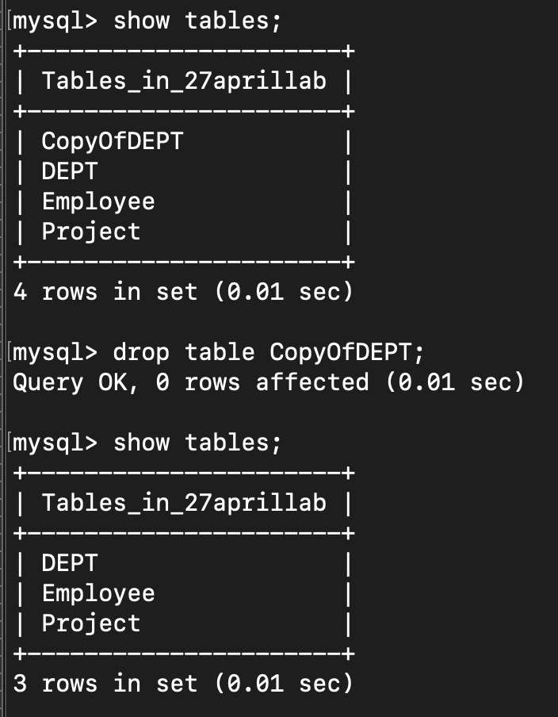

**Exercise - 3:**

**Aim:** To know how the constraints are used to make table consistent.

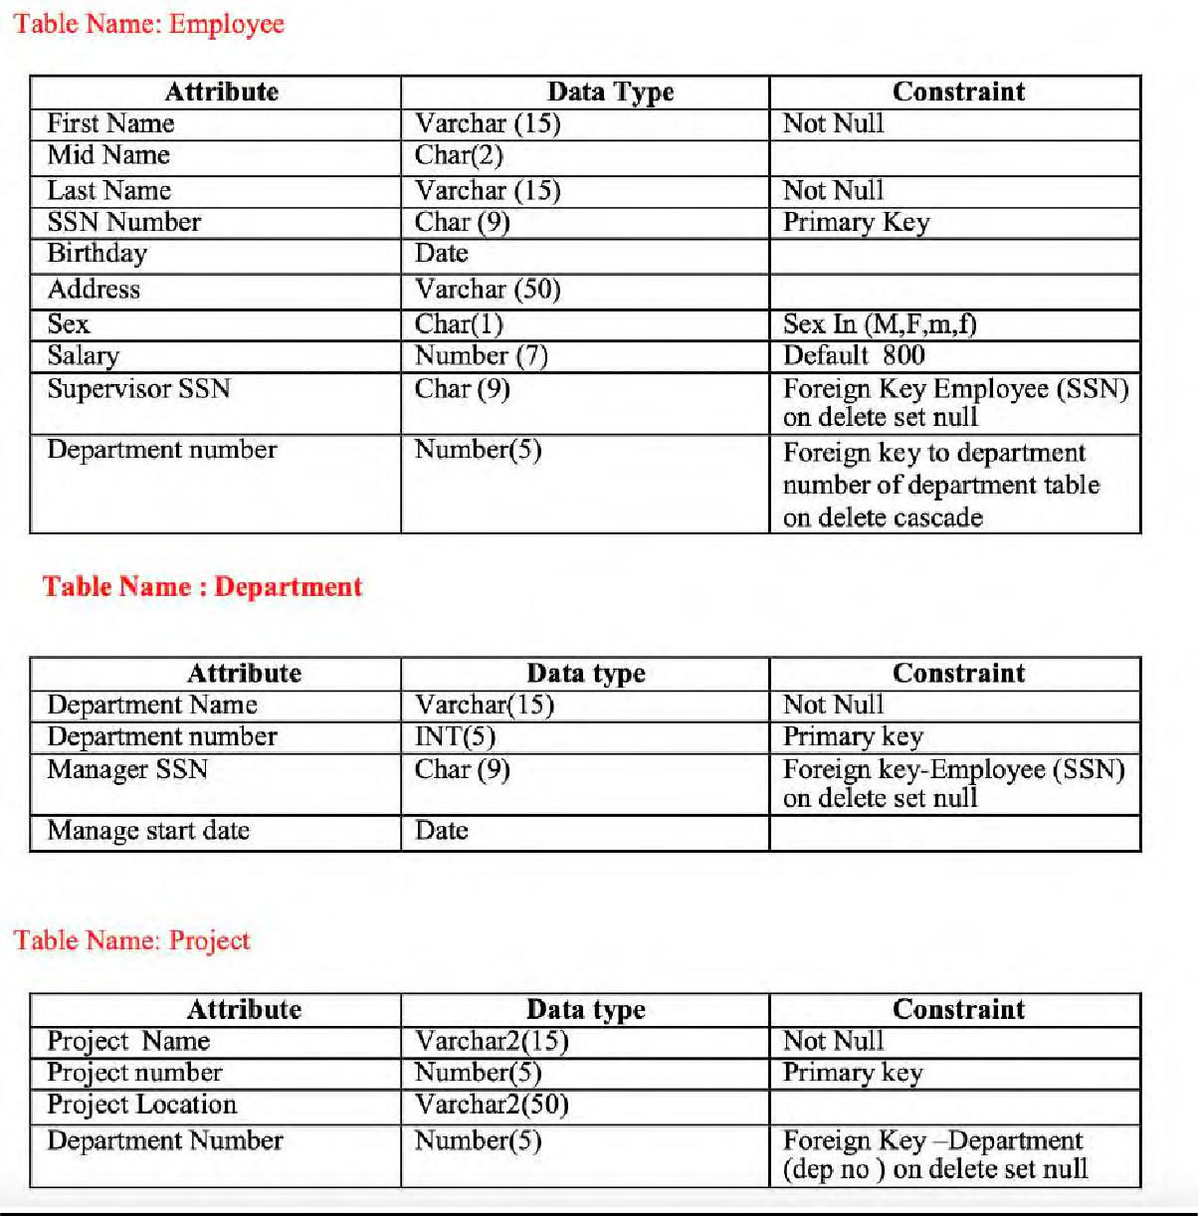

# Creating the tables:

SQL Commands:

create table Employee(First_Name varchar(15),Mid_Name char(2) , Last_Name varchar(15), SSN_Number char(9), Birthday date, Address varchar(50), Sex char(1), Salary integer(7), Supervisor_SSN char(9), Department_Number integer(5));

create table Department (Department_Name varchar(15), Department_Number integer(5), Manager_SSN char(9), Manage_Start_Date date);

create table Project(Project_Name varchar(15), Project_Number integer(5), Project_Location varchar(15), Department_Number integer(5));

Screenshot:





# Applying Constraints:

alter table Employee modify First_Name varchar(15) not null;

alter table Employee modify Last_Name varchar(15) not null; alter table Employee add primary key(SSN_Number);

alter table Employee add check(Sex = 'M' OR Sex = 'F' OR Sex = 'm' OR Sex = 'f');

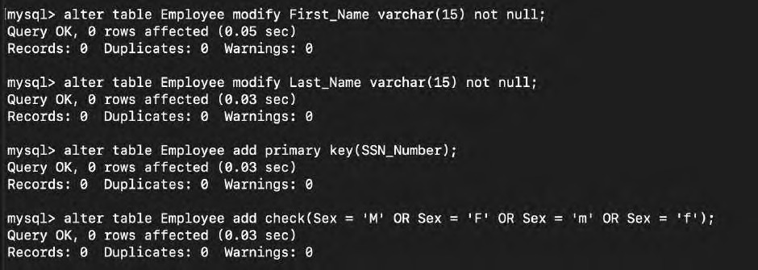

alter table Employee alter Salary set Default '800’;

alter table Employee add foreign key (Supervisor_SSN) references Employee(SSN_Number);

alter table Department add primary key(Department_Number);

alter table Employee add foreign key (Department_Number) references Department(Department_Number);

alter table Department modify Department_Name varchar(15) not null;

alter table Department add foreign key (Manager_SSN) references Employee(SSN_Number);

alter table Project modify Project_Name varchar(15) not null;

alter table Project add primary key(Project_Number);

alter table Project add foreign key (Department_Number) references Department(Department_Number);

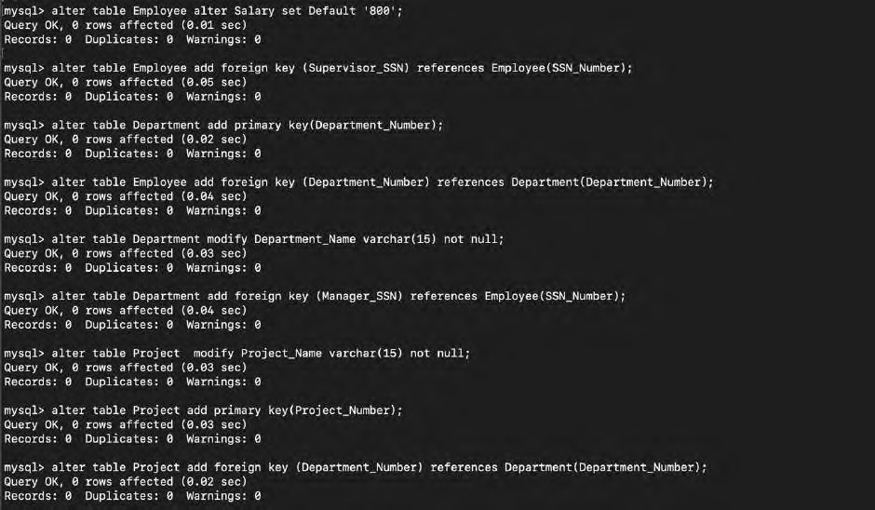

alter table Department add constraint FK_DepManagerSSN foreign key (Manager_SSN) references Employee(SSN_Number) on delete set null;

alter table Employee add constraint FK_EmpDepartmentNumber foreign key (Department_Number) references Department(Department_Number) on delete cascade;

alter table Project add constraint FK_ProDepartmentNumber foreign key (Department_Number) references Department(Department_Number) on delete set null;

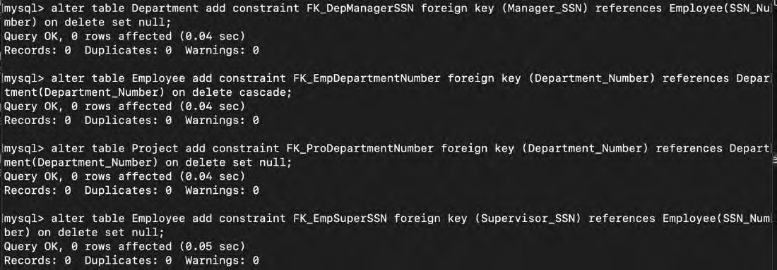alter table Employee add constraint FK_EmpSuperSSN foreign key (Supervisor_SSN) references Employee(SSN_Number) on delete set null;

# Table Description after constraints:

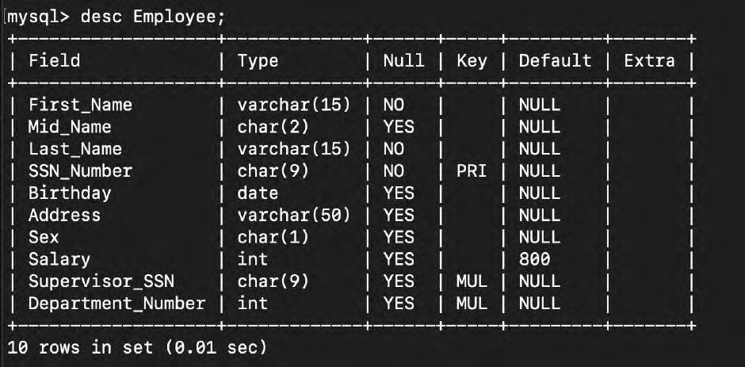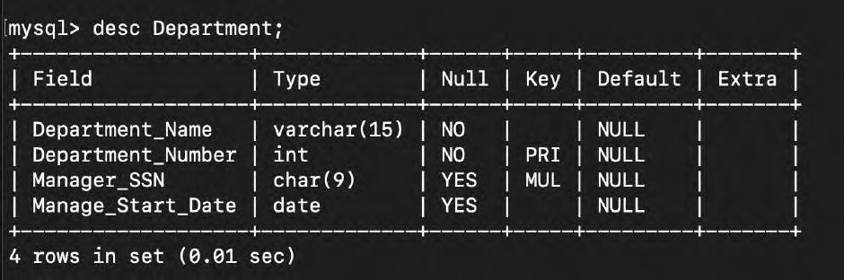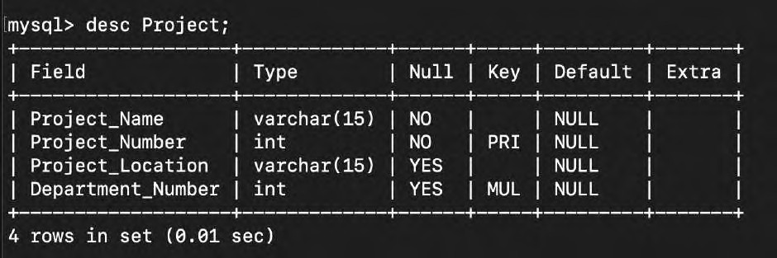

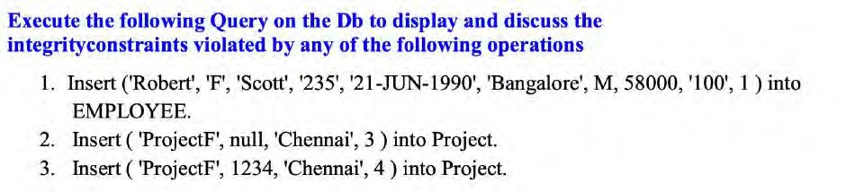

**Inserting the data:**

SQL Command:

insert into Employee (First_Name, Mid_Name, Last_Name, SSN_Number, Birthday, Address, Sex, Salary, Supervisor_SSN

, Department_Number) values ('Robert', 'F', 'Scott', '235', '1990-07-21', 'Bangalore', 'M', '58000', '100', '1');

Screenshot:

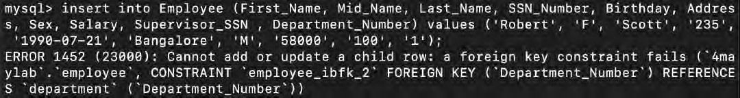

Error Reason:

Since department no. 1 doesn’t exist yet, we cannot assign the department no. 1 to the new Employee.

# Inserting the data:

SQL Command:

insert into Project (Project_Name, Project_Number, Project_Location , Department_Number) values ('ProjectF', 'null', 'Chennai', '3');

Screenshot:

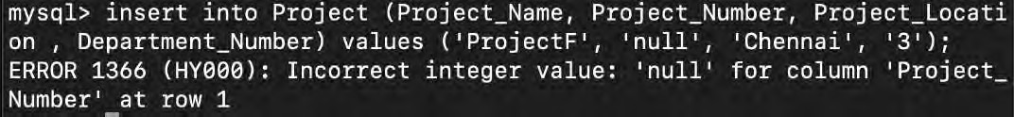

Error Reason:

Project_Number cannot be set to null since it has a constraint of not null.

# Inserting the data:

SQL Command:

insert into Project (Project_Name, Project_Number, Project_Location , Department_Number) values ('ProjectF', '1234', 'Chennai', '4');

Screenshot:

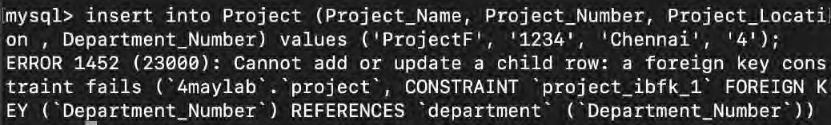

Error Reason:

Since no department no. 4 exists, we cannot assign it to the project.

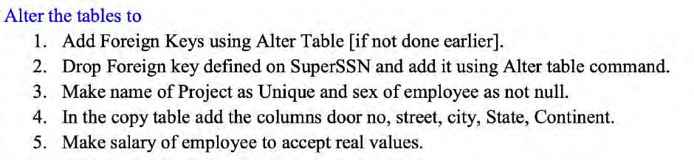

# Adding Foreign Keys:

SQL Commands:

alter table Department add constraint FK_DepManagerSSN foreign key (Manager_SSN) references Employee(SSN_Number) on delete set null;

alter table Employee add constraint FK_EmpDepartmentNumber foreign key (Department_Number) references Department(Department_Number) on delete cascade;

alter table Project add constraint FK_ProDepartmentNumber foreign key (Department_Number) references Department(Department_Number) on delete set null;

alter table Employee add constraint FK_EmpSuperSSN foreign key (Supervisor_SSN) references Employee(SSN_Number) on delete set null;

Screenshot:

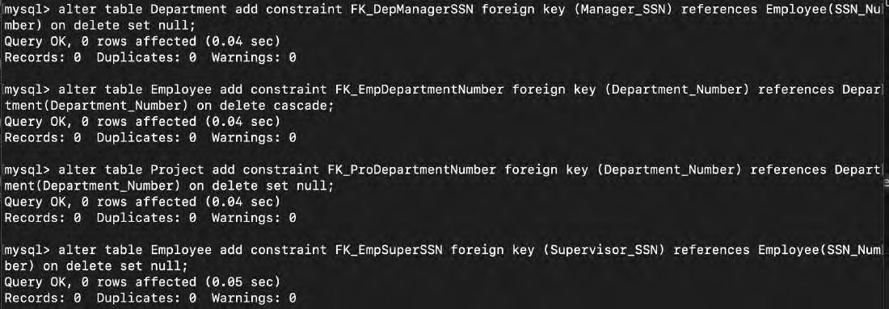

# Dropping and adding the Foreign Key:

SQL Commands:

alter table Employee drop constraint FK_EmpSuperSSN;

alter table Employee add constraint FK_EmpSuperSSN foreign key (Supervisor_SSN) references Employee(SSN_Number) on delete set null;

# Screenshot:

**Making Project Name unique:**

SQL Commands:

alter table Project add unique(Project_Name);

Screenshot:

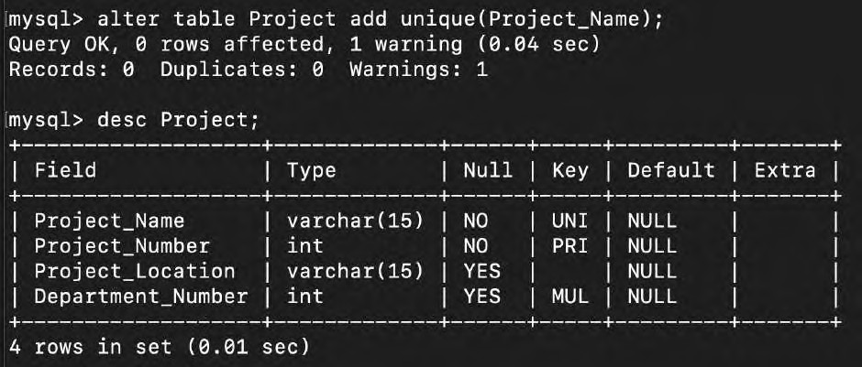

# Making Employee Sex not null:

SQL Commands:

alter table Employee modify Sex char(1) not null;

Screenshot:

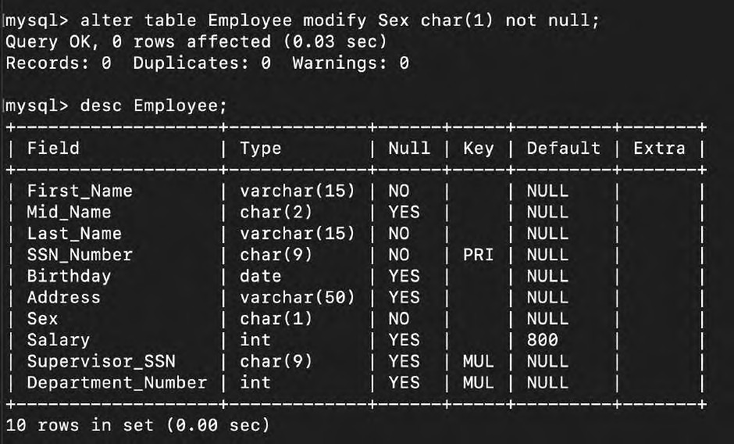

# Making a copy table and adding new columns:

SQL Commands:

create table CopyOfEmployee like Employee;

insert into CopyOfEmployee Select * from Employee;

|  |  |  |  |  |
| --- | --- | --- | --- | --- |
| alter | table | CopyOfEmployee | add | DoorNo varchar(50); |
| alter | table | CopyOfEmployee | add | Street varchar(50); |
| alter | table | CopyOfEmployee | add | City varchar(50); |
| alter | table | CopyOfEmployee | add | State varchar(50); |
| alter | table | CopyOfEmployee | add | Continent varchar(50); |

Screenshot:

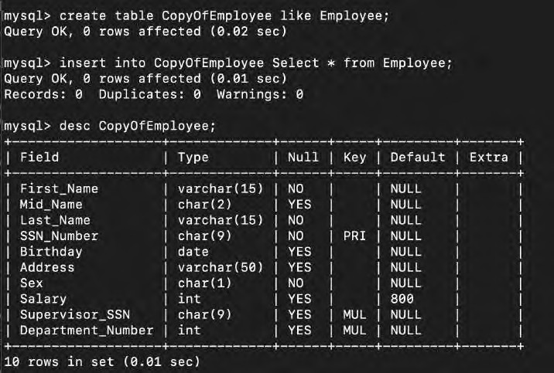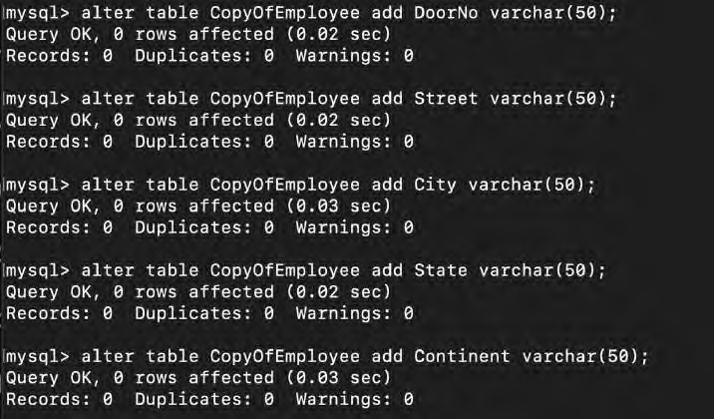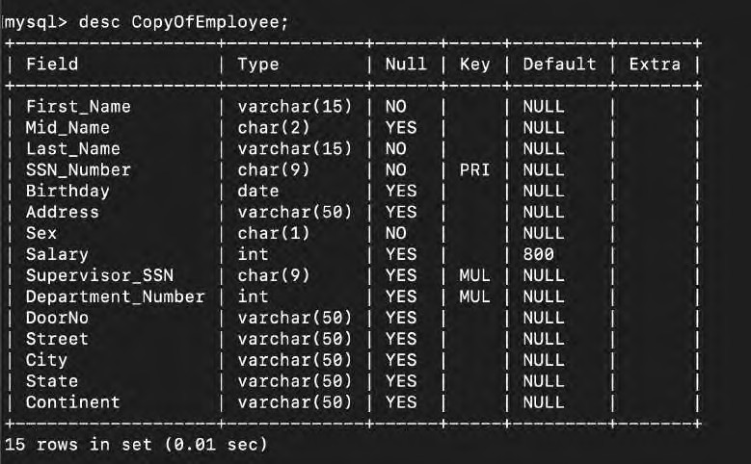

# Making the salary to accept real values:

SQL Command:

alter table Employee add constraint SalaryPos check(Salary>=0);

Screenshot:

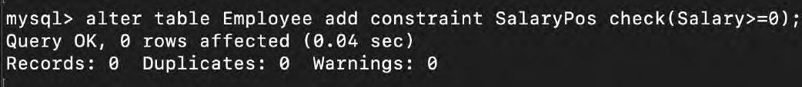

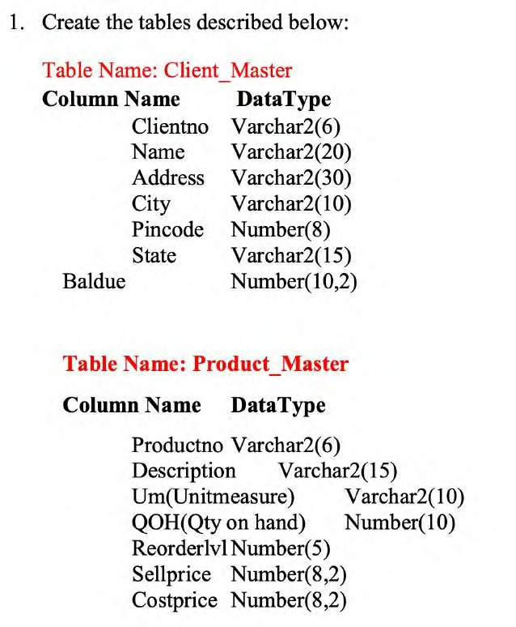**Exercise – 4**

Creating Table:

SQL Command:

Create Table Client_Master(Clientno varchar(6),Name varchar(20),Address varchar(30),City varchar(10),Pincode int(8),State varchar(15),Baldue decimal(10,2));

Create Table Product_Master(Product_No varchar(6), Description varchar(15),unit_measure varchar(10),quan_on_hand int(10),reorder_lvl int(5),sell_price decimal(8,2),cost_price decimal(8,2));

Screenshot:

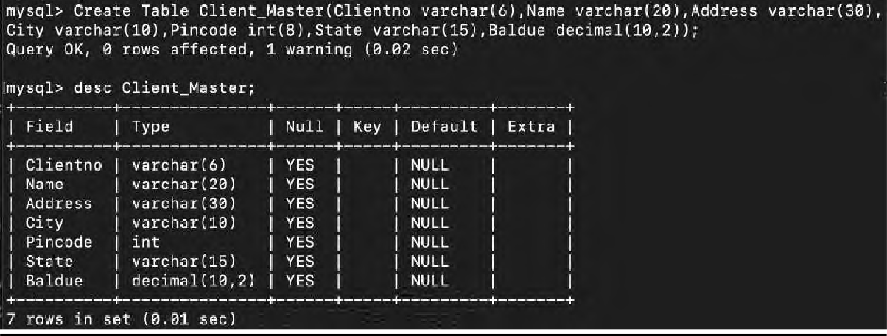

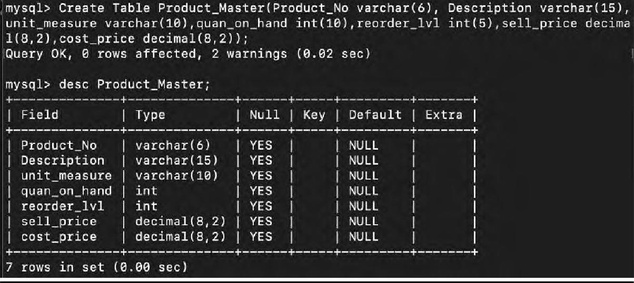

Inserting the data in Client_Master:

SQL Commands:

insert into Client_Master values('C00001','ASHA','A/14,WORLI','MUMBAI',400054,'MAHARA SHTRA',15000);

insert into Client_Master values('C00002','LAKSHMI','65 NARIMAN','BANGLORE',560001,'KARNATAKA',0);

insert into Client_Master values('C00003','PUJA','P- 76,BANDRA','MUMBAI',400002,'MAHARASTRA',10000);

insert into Client_Master values('C00004','SHANKAR','A/6,JUHU','MANGLORE',400044,'KAR NATAKA',5000);

insert into Client_Master values('C00005','DEEPAK','68,TNAGAR','CHENNAI',6320018,'TAM ILNADU',0);

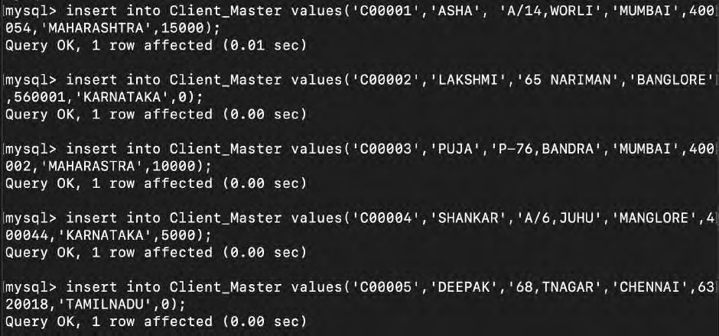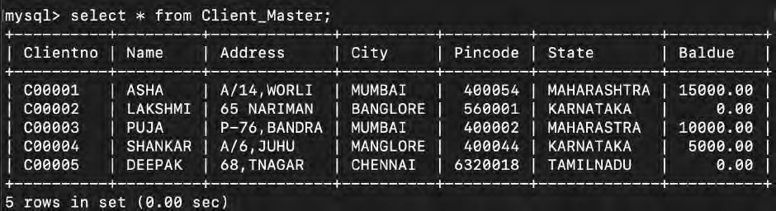Screenshot:

Inserting the data in Product_Master: SQL Commands:

insert into Product_Master values('P00001','T- SHIRTS','PIECE',200,40,350,250);

insert into Product_Master values('P0345','SHIRT','PIECE',150,50,500,350);

insert into Product_Master values('P06744','COTTON JEANS','PIECE',50,20,600,450);

insert into Product_Master values('P0990','CHUDDY','PIECE',100,40,400,250);

insert into Product_Master values('P08823','SARRIES','PIECE',60,50,500,300);

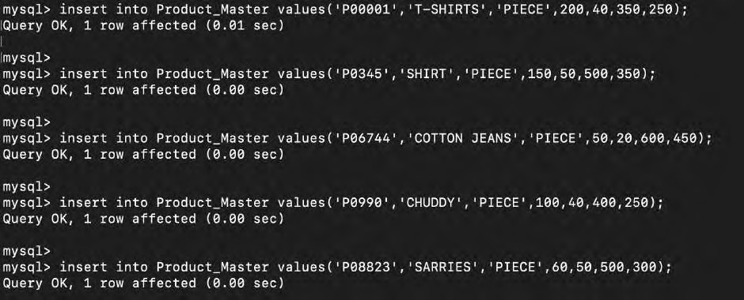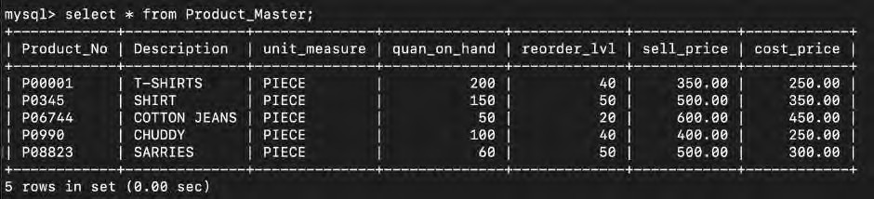Screenshot:

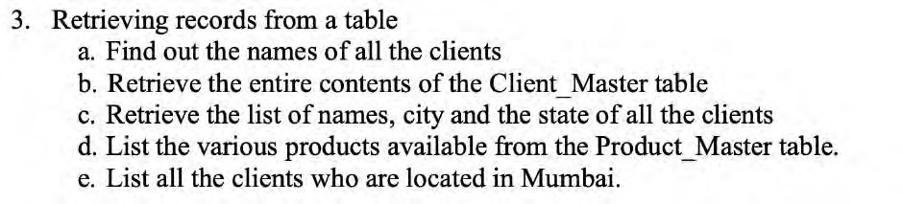

1. SQL Command:

select name from Client_Master;

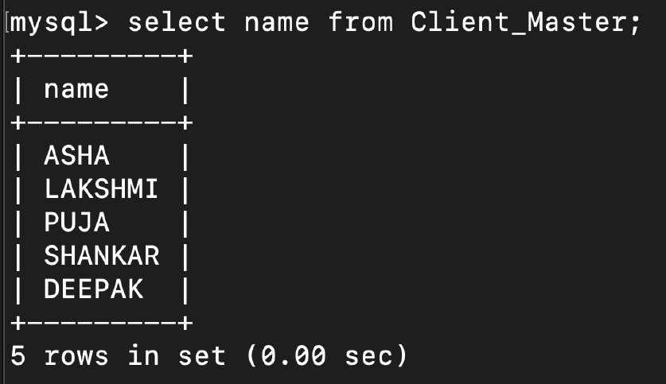Screenshot:

1. SQL Command:

select * from Client_Master;

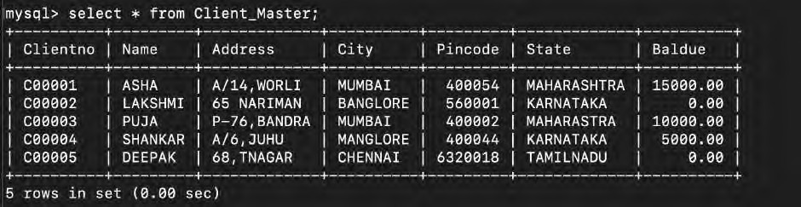Screenshot:

1. SQL Command:

select name,city,state from Client_Master

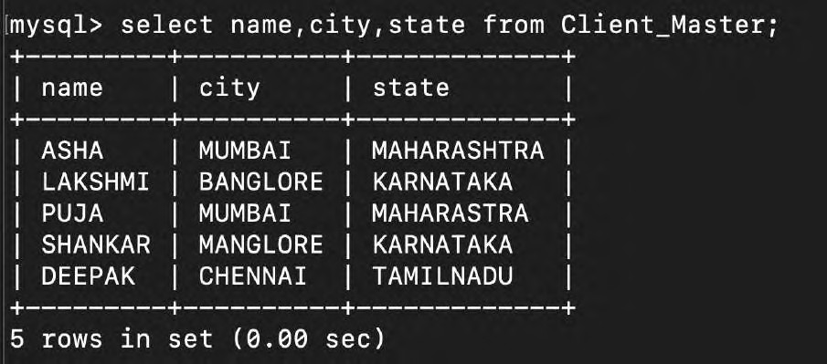Screenshot:

1. SQL Command:

select distinct description from Product_Master;

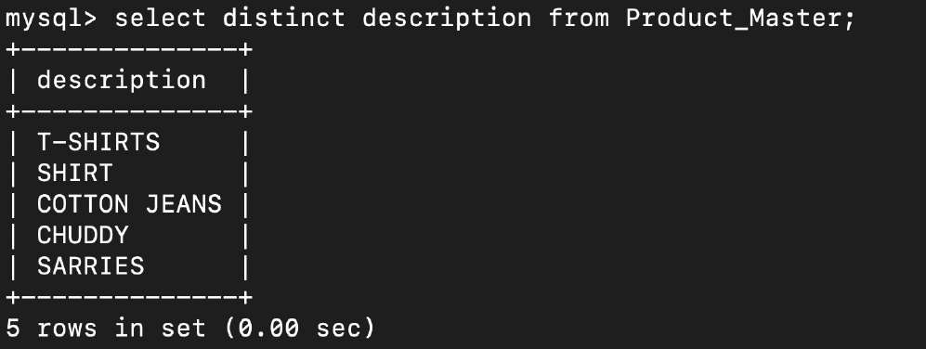Screenshot:

1. SQL Command:

select * from client_master where City = 'MUMBAI';

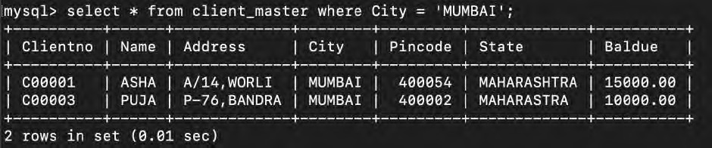Screenshot:

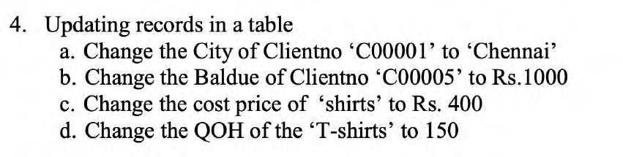

1. SQL Command:

update Client_Master set CITY='CHENNAI' where clientno='C00001';

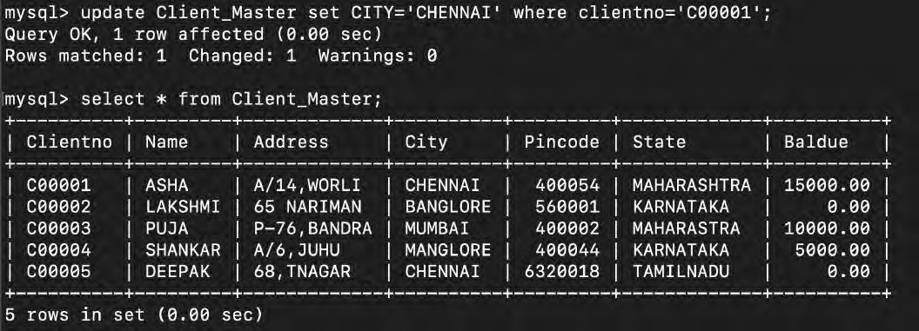Screenshot:

1. SQL Command:

update Client_Master set Baldue=1000 where ClientNo = 'C00005';

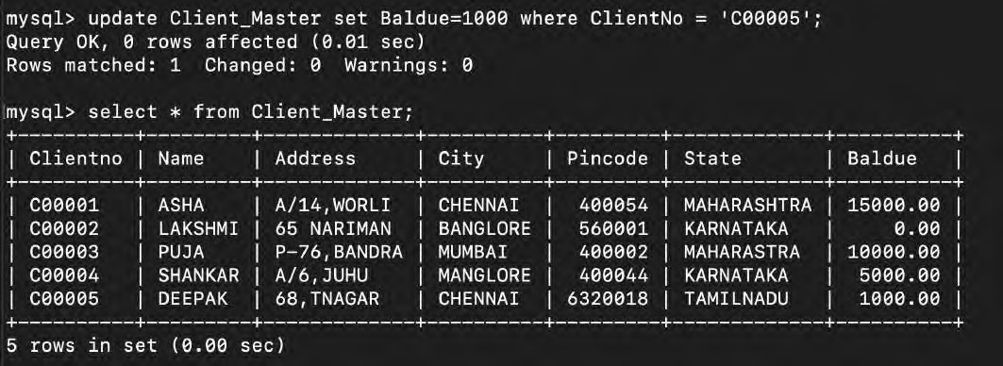Screenshot:

1. SQL Command:

update Product_Master set cost_price=400 where DESCRIPTION='SHIRT';

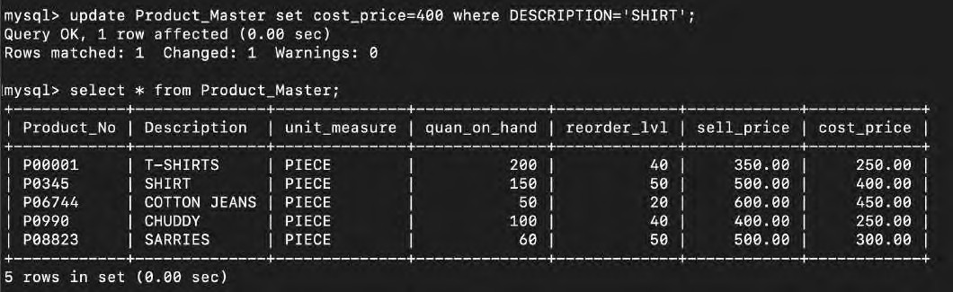Screenshot:

1. SQL Command:

update Product_Master set quan_on_hand=150 where description='T-SHIRTS';

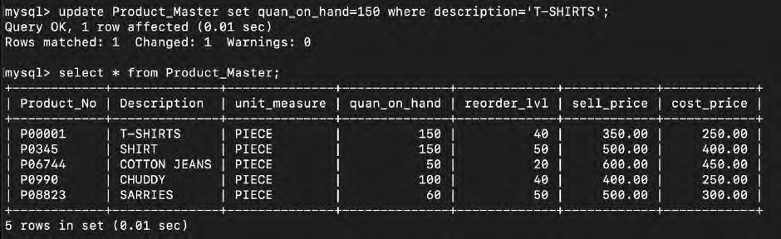Screenshot:

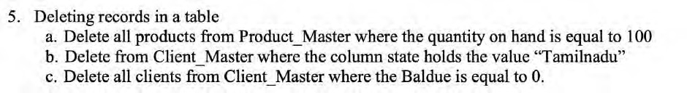

1. SQL Command:

delete from Product_Master where quan_on_hand=100;

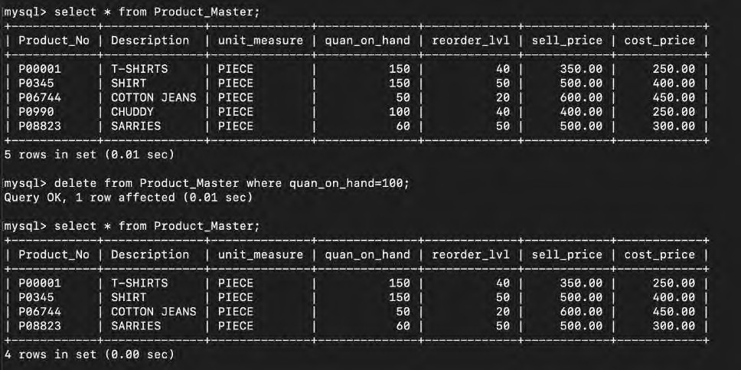Screenshot:

1. SQL Command:

delete from client_master where state='TAMILNADU';

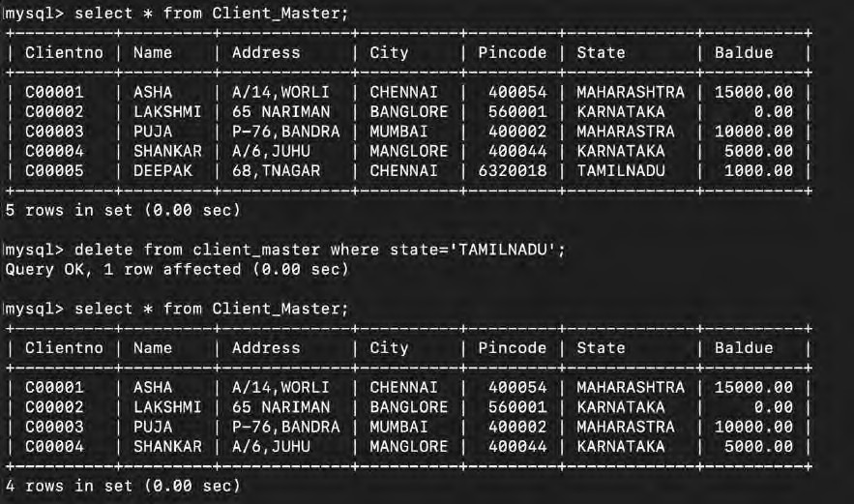Screenshot:

1. SQL Command:

delete from client_master where BALDUE=0;

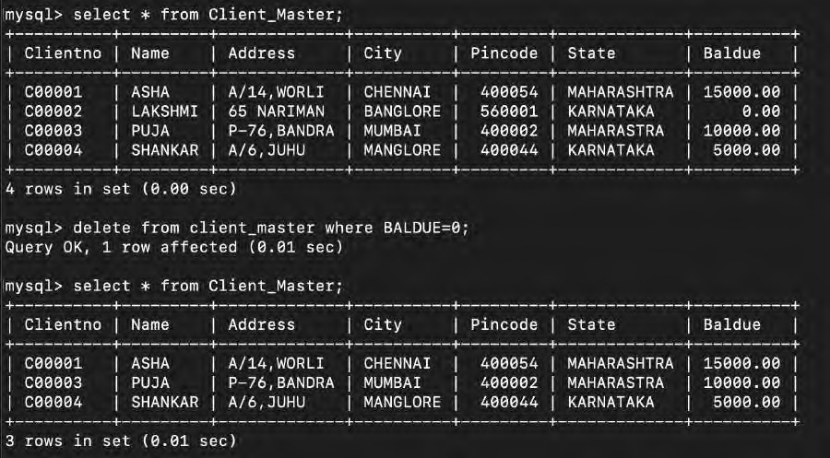Screenshot:

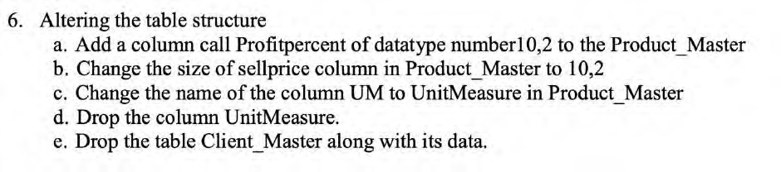

1. SQL Command:

alter table Product_Master add Profit_percent decimal(10,2);

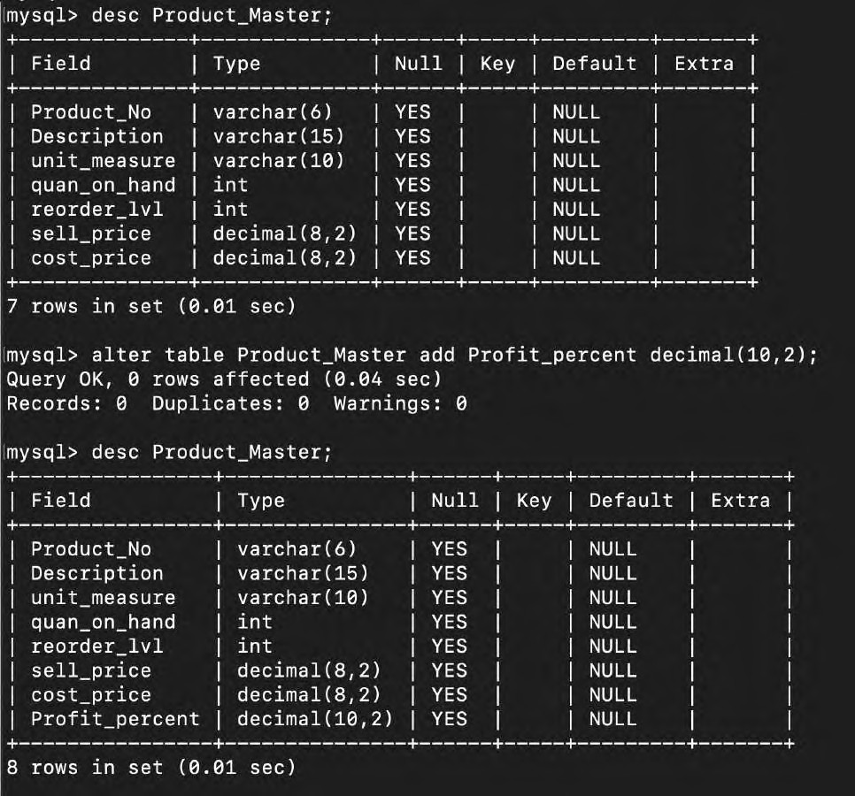Screenshot:

1. SQL Command:

alter table product_master modify Sell_price decimal(10,2);

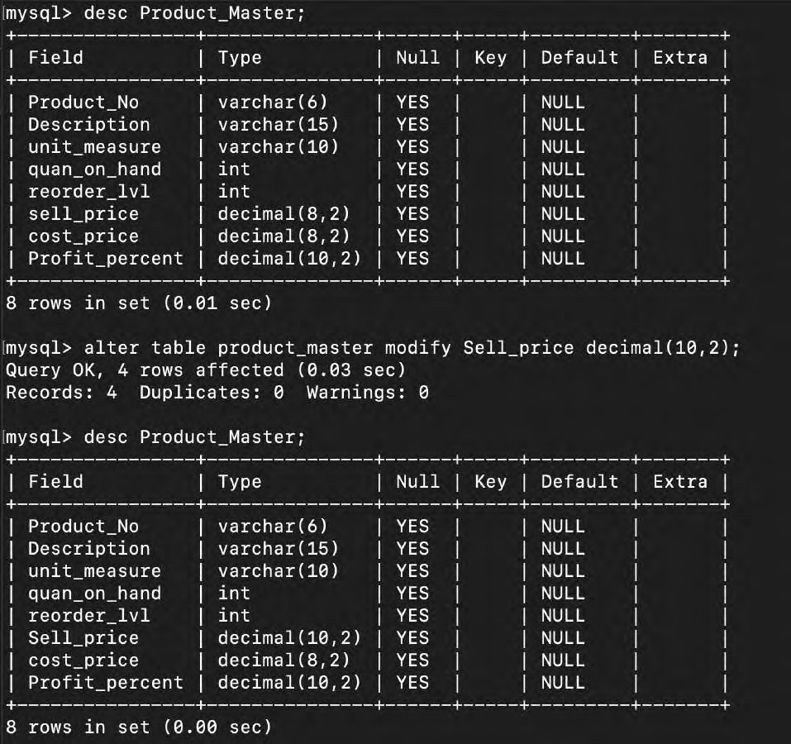Screenshot:

alter table product_master rename column unit_measure to UNITmeasure;

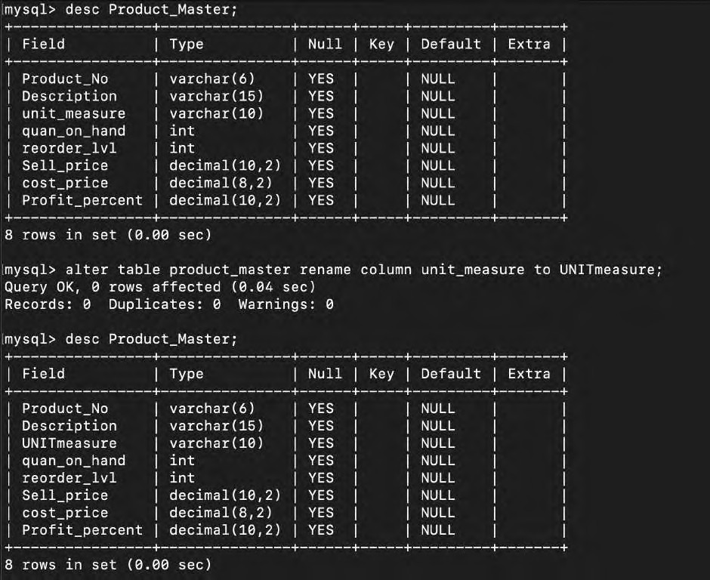Screenshot:

d. SQL Command:

alter table Product_Master DROP COLUMN UNITmeasure;

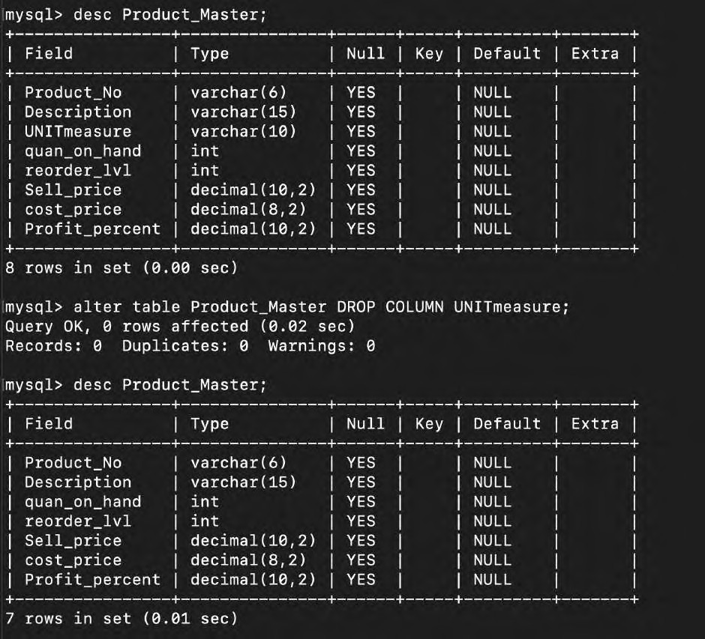Screenshot:

e. SQL Command:

drop table Client_Master;

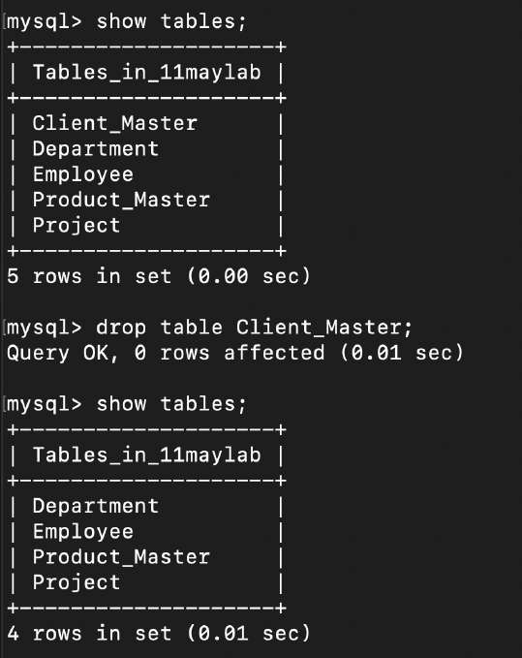Screenshot:

**Operators In SQL:**

**Creating the table and inserting data:**

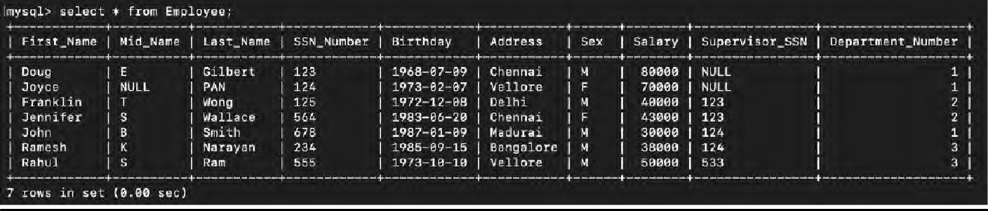

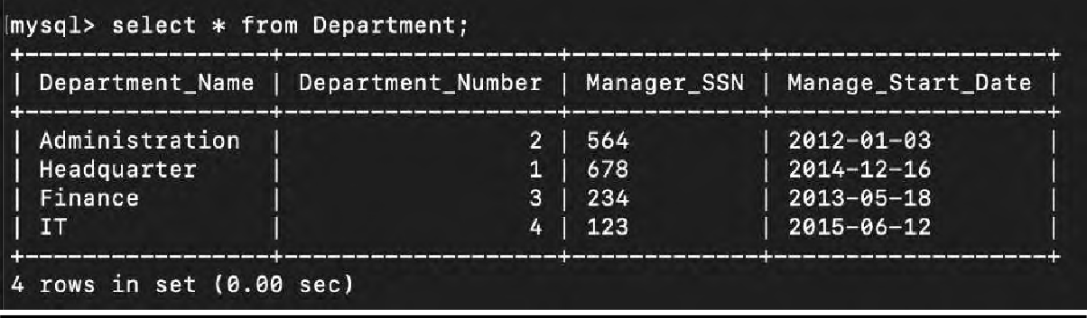

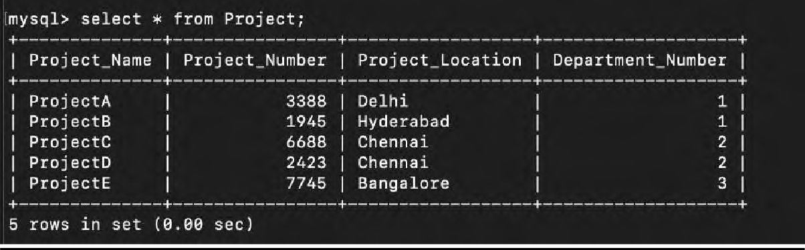

# Find the employee names having salary greater than Rs.45000.

SQL Command:

select First_Name, Mid_Name, Last_Name,Salary from Employee where Salary>=45000;

Screenshot:

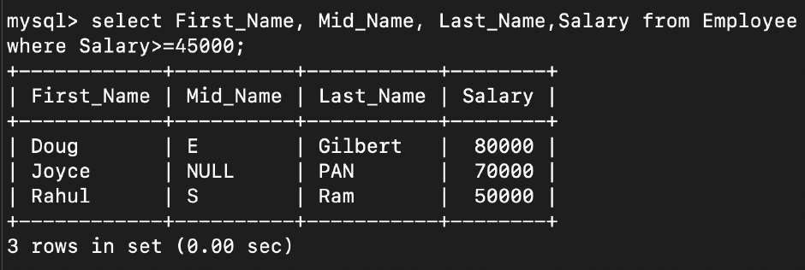

# Find the employee names whose salary lies in the range between 35000 and 75000

SQL Command:

select First_Name, Mid_Name, Last_Name,Salary from Employee where 35000<=Salary<=75000;

Screenshot:

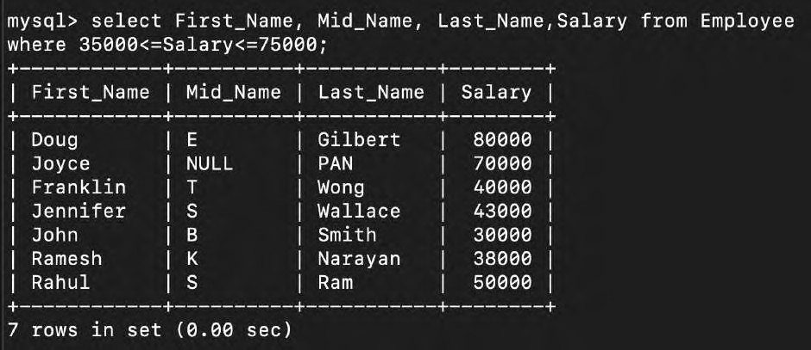

# Find the employee who have no supervisor

SQL Command:

select First_Name, Mid_Name, Last_Name from Employee where Supervisor_SSN is null;

Screenshot:

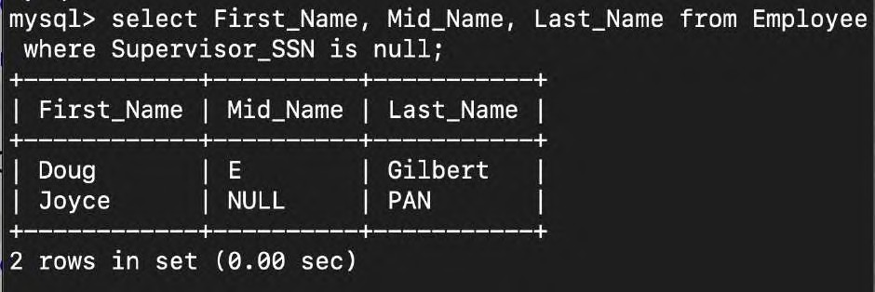

# Display the employee names having ‘salt lake’ in their address.

SQL Command:

select First_Name, Mid_Name, Last_Name from Employee where Address like '%Salt Lake%';

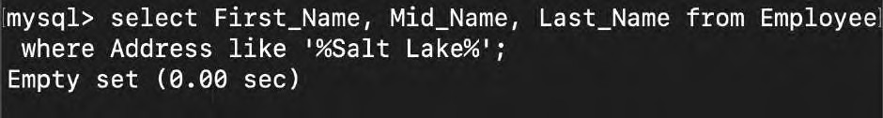Screenshot:

# Display the department name that starts with ’H’.

SQL Command:

select Department_Name from Department where Department_Name like 'H%';

Screenshot:

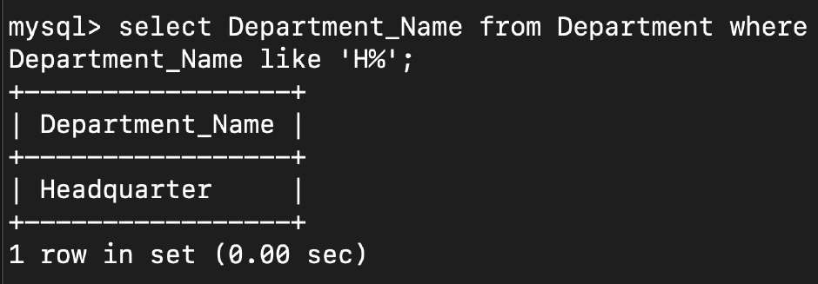

# Display the project numbers along project name that ends with ‘i’ in project location.

SQL Command:

Select Project_Name, Project_Number,Project_Location from Project where Project_Location like '%i';

Screenshot:

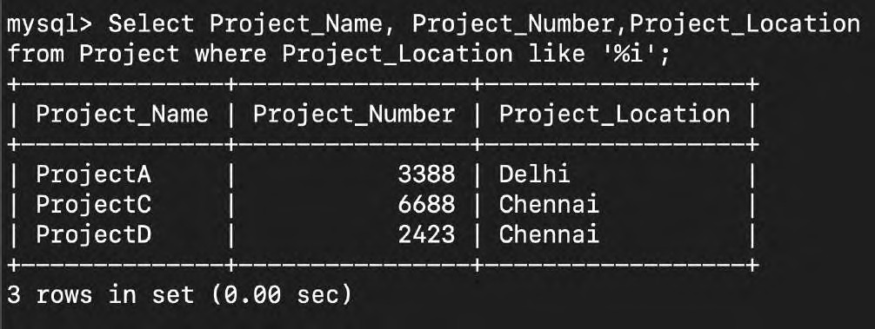

# Display the names of all the employees having supervisor with any of the following SSN 123, 533.

SQL Command:

select First_Name, Mid_Name, Last_Name, Supervisor_SSN from Employee where Supervisor_SSN = 123 OR Supervisor_SSN = 533;

Screenshot:

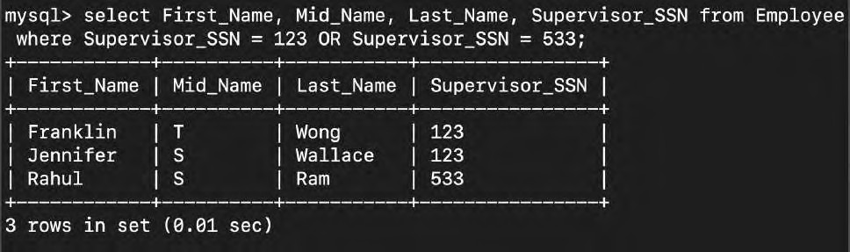

# Display all the employee details based on the salary in descending order.

SQL Command:

select First_Name, Mid_Name, Last_Name,Salary from Employee order by Salary DESC;

Screenshot:

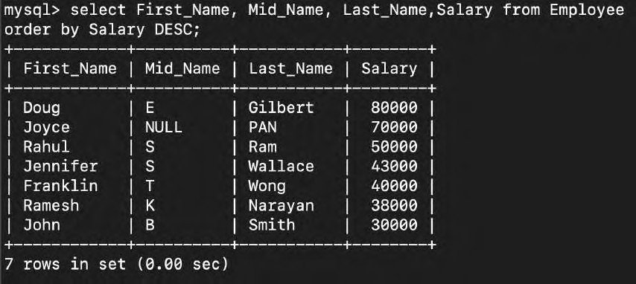

# Display the employees belongs to Chennai or vellore.

SQL Command:

select * from Employee where Address = 'Chennai' OR Address

= 'Vellore';

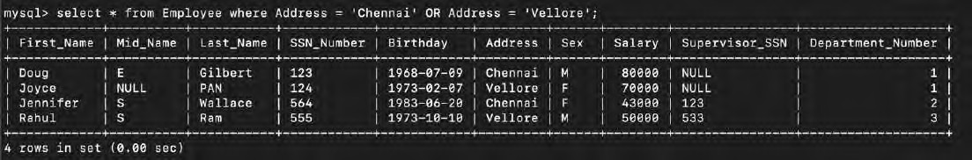Screenshot:

# Display the department details in ascending order of department number.

SQL Command:

Select * from Department order by Department_Number;

Screenshot:

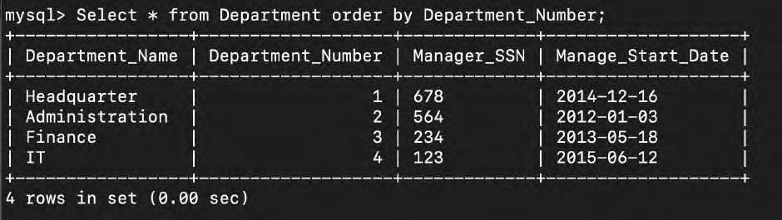

# Display all the MgrSSN and MgrStartDate as ManagerSSN and Manager_DOJ.

SQL Command:

Select Manager_SSN as ManagerSSN, Manage_Start_Date as Manager_DOJ from Department;

Screenshot:

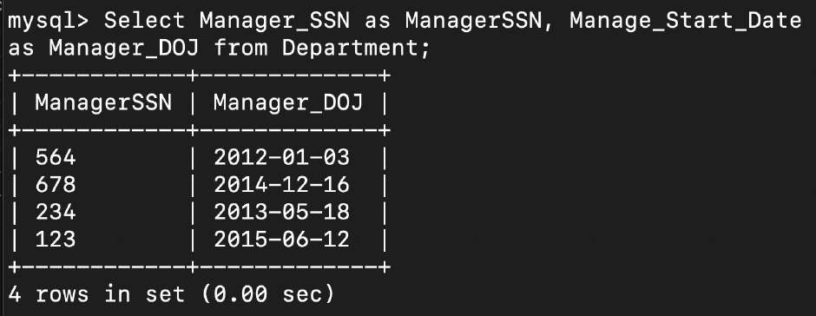

# Display all the male employees with SSN and salary

SQL Command:

select SSN_Number, Salary from Employee where Sex = 'M';

Screenshot:

